Algebra 1 Unit 2B Test ~ Study Guide Name ________________________
Functions

1. For the given function
f(x) = 2x + 7, find f (–2).

a. f(–2) = 11
b. f(–2) = 3
c. f(–2) = –3
d. f(–2) = 18

2. For the given function
f(x) = 4x–6, which x value would make f(x) = 30?

a. x = 6
b. x = 9
c. x = 7
d. x = 30

3. In the following table, find the domain when the range is 1.
x | –3 | –2 | –1 | 0 | 1 | 2 | 3
f(x) | 0 | 1 | 2 | 3 | 4 | 5 | 6

a. 1
b. 0
c. –2
d. 4

~~~~~~~~~~~~~~~~~~~~~~~~~~~~~~~~~~~~~~~~~~~~~~~~~~~~~~~~~~~~~~~
Linear Characteristics
4. Graph the function and determine the key characteristics.

f(x) = 2x + 4
Domain:

Range:
x-intercept:

y-intercept:

Increasing or Decreasing?

Where?

End Behavior:

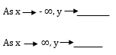

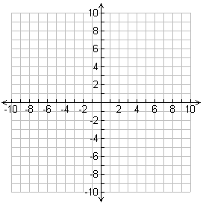

~~~~~~~~~~~~~~~~~~~~~~~~~~~~~~~~~~~~~~~~~~~~~~~~~~~~~~~~~~~~~~~
Use the graph below to answer questions 5 – 8

5. What is x when f(x) = 5?

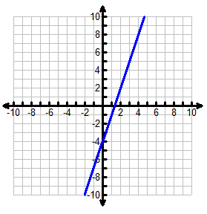
6. What is the domain of the function?

7. What is the end-behavior, as x approaches positive infinity of the function modeled?

8. Write the function being modeled by the above graph.

Rate of Change

9. Find the rate of change of the following ordered pairs: (10, 1) and (15, –9)

10. Find the slope of the function: 3x – 6y = 12

11. The tables below model two linear functions.
Function 1 Function 2
x | f(x)
1 | 3
2 | 1
3 | –1
4 | –3

x | f(x)
1 | 5
2 | 4
3 | 3
4 | 2

Which of the linear functions below has a slope greater than the slope for Function 1 but less than
the slope for Function 2?

a. f(x) = –1.5x–2 b. f(x) =–2x–4 c. f(x) = –2.5x + 3 d. f(x) = –3x + 6

~~~~~~~~~~~~~~~~~~~~~~~~~~~~~~~~~~~~~~~~~~~~~~~~~~~~~~~~~~~~~~~
Arithmetic Sequences
Term  Number | Value of  Term
1 | 2
2 | 7
3 | 12
4 | 17
n | ?
12. The table to the right shows the relationship between the number of a term in a pattern and the value of that term. Write a formula to represent the table.

13. The second term of an arithmetic sequence is a₂ = 24. The common difference is d = –3. Find the first term of the sequence.

14. Pizza King sells pizza for $6 per pizza and a $4 delivery fee.

n | a_{n}
0
1
2
3
4
a. Write a function to model this situation.

b. Complete the table.

c. How much money do you owe Pizza King for ordering 25 pizzas?

15. Find a₁₅ for the sequence
a_{n} = 2n + 5.

16. Write a function that could be used to represent the sequence: 5, 11, 17, 23, …

17. Find a₃₀ for the sequence
a_{n} = 2n – 12

~~~~~~~~~~~~~~~~~~~~~~~~~~~~~~~~~~~~~~~~~~~~~~~~~~~~~~~~~~~~~~~
Determine if the following are even, odd, or neither.
16. f(x) = –5x⁴ + 3x – 1 17. f(x) = 2x⁵ + x 18. f(x) = 2x⁴ + 7x² – 7
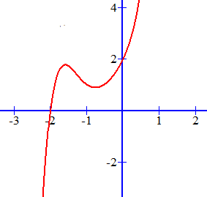
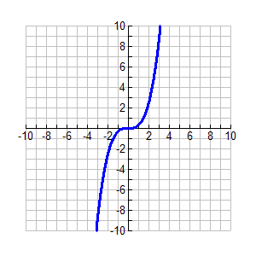
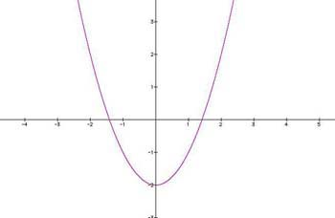
19. 20. 21.

~~~~~~~~~~~~~~~~~~~~~~~~~~~~~~~~~~~~~~~~~~~~~~~~~~~~~~~~~~~~~~~
22. Jalen makes $14 per hour babysitting plus a flat rate of $5 for gas. Write the function. Name the slope and y-intercept.

~~~~~~~~~~~~~~~~~~~~~~~~~~~~~~~~~~~~~~~~~~~~~~~~~~~~~~~~~~~~~~~
23. For the following table:
x | 1 | 2 | 3 | 4 | 5 | 6
y | 10 | 7 | 4 | –2 | –5 | –8

a) Is the relation a function?

b) What is the domain?

c) What is the range?

d) What is the rate of change?

~~~~~~~~~~~~~~~~~~~~~~~~~~~~~~~~~~~~~~~~~~~~~~~~~~~~~~~~~~~~~~~
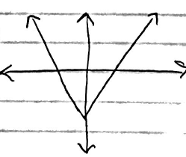
26. Determine if the following are functions:
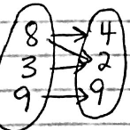
a) b)

