Geometry Milestone Test |  |  |  | Name ________________________________ S: _____
1. A regular pentagon is centered about the origin and has a vertex at (0, 4). Which transformation maps the pentagon onto itself?  A. a reflection across line m.  B. a reflection across the x-axis.  C. a clockwise rotation of 100° about the origin.  D. a clockwise rotation of 144° about the origin. |  |  | 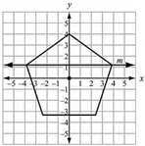 | 2. Triangle A’B’C’ in Q1 is:  a. A translation of triangle ABC across the x-axis.  b. A 270⁰ rotation of triangle ABC about the origin.  c. A reflection of triangle ABC across the y-axis.  d. A reflection of triangle ABC across the x-axis. |  | 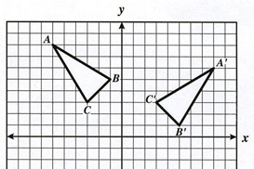
3) In the coordinate plane, segment $\overline{PQ}$ is the result of a dilation of segment $\overline{XY}$ by a scale factor of $\frac{1}{2}$ . What is the point of dilation?  A. (–4, 0) B. (0, –4)  C. (0, 4) D. (4, 0) |  | 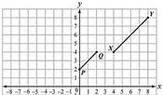 |  | 4. Triangle △ABC is dilated by a factor of $\frac{2}{3}$ to form △XYZ. Given that m∠A = 50° and m∠B = 100°, what is m∠Z?  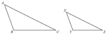  A. 15° B. 25°  C. 30° D. 50°
5) What is the rule for a 90 degree counterclockwise rotation about the origin?  A. $(-Y, X)$  B. $(Y, -X)$  C. $(-X, -Y)$  D. $(X, -Y)$ | 6. Point $(-4, 3)$ is reflected about the line $y=-5$. What is the new point?  A. $(-6, 3)$  B. $(-3, 3)$  C. $(-4, 5)$  D. $(-4, -13)$ |  |  | 7. This partially completed construction is of a . . .  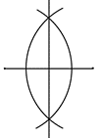  A. Angle Bisector  B. Tangent Line  C. Parallel Lines through a point  D. Perpendicular Bisector | 8. What is the length of $\overline{EG}?$  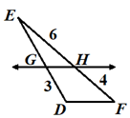  A. 5.5  B. 5  C. 4.5  D. 4
9. ABCD is a square. Which two properties can’t be used to prove $∆ABD≅∆CDB$?  A. Vertical angles  B. Reflexive sides  C. Alternate Interior Angles  D. Corresponding angles |  | 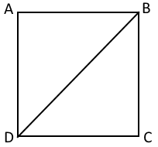 |  | 10. What congruency rule proves $∆ENV≅∆LOV?$  A. SSA  B. SAS  C. HL  D. Not possible | 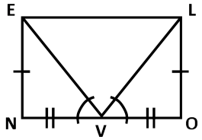

11. In a right $∆ABC$, C is the right angle. If $sin A=\frac{5}{13},$what is cos A?  a. b. c. d. |  |  | 12. A 6 ft tall man casts a shadow 14 feet long. What is the angle of elevation that the sun ray makes with the ground to the nearest whole number?  a. $19°$ b. $21°$ c. $23°$ d. $25°$ |  |  |  | 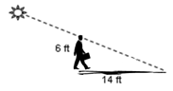
13. A hot air balloon is 1200 feet above the ground. The angle of depression from the basket to the base of a monument is 58 degrees. What is the distance, d, from the balloon to the base of the monument to two decimals?  A. 1.017.66 ft B. 1,200 ft  C. 1,386.45 D. 1,415.01 ft |  | 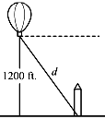 |  | 14. What is the length of Y? 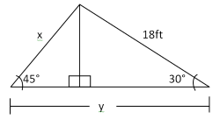  A. $9\sqrt{2}$ ft  B. $9\sqrt{3}$ ft  C. $9+\sqrt{3}$ft  D. $9+9\sqrt{3}$ft | 15. Find x.  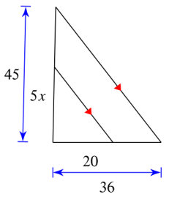  A. 4 B. 5  C. 7 D. 8
16. Find the volume of the cylinder to the nearest tenth.  A. 1,026,484.0 mm³ B. 256,621.0 mm³  C. 85,540.3 mm³ D. 5,270 mm³ |  |  |  |  |  | 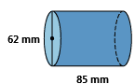
17. A triangular prism has an isosceles right triangle as a base. Each leg of the base is 7.2 cm long and the height of the prism is 13.2 cm. Fine the volume of the prism.  A. 342.1 cm² B. 646.8 cm²  C. 684.3 cm³ D. 228.1 cm³ |  |  |  |  |  | 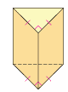
18. What is the radius of a sphere with a volume of 8,181.2 cm³?
A. 10 cm B. 11 cm C. 12 cm D. 12.5 cm
19. Find the volume and surface area of the rectangular prism.  A. $5.51 m^{3}, {19.08 m}^{3}$ B. $19.08 m^{3}, {5.51 m}^{3}$  C. $6.75 m^{3}, {19.08 m}^{3}$ D. $19.08 m^{3}, {6.75 m}^{3}$ |  |  |  |  |  | 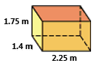
20. Find the volume of each hemisphere. Round to the nearest hundredth.  A. $14,137.17 {cm}^{3}$ B. $15,255.10 {cm}^{3}$  C. $7,627.55 {cm}^{3}$ D. $7,068.58 {cm}^{3}$ |  |  |  |  |  | 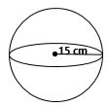
21. If a marble has a volume of 523.6 mm³, how many whole marbles can fit in the cone, ignoring empty space?  A. 4,608 B. 4,607  C. 3,299 D. 4,806 |  |  |  |  |  | 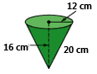
22. If each of the following solids has a height of 8 cm, which has the greatest volume?
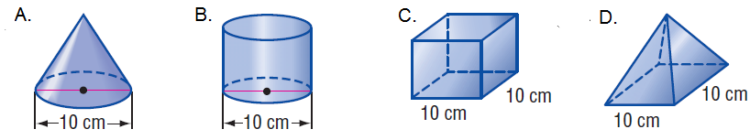
23. Find x.  A. 3 B. 4  C. 5 D. 6 |  | 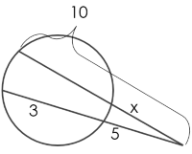 |  | 24. Find the perimeter.  A. 70 cm B. 73 cm  C. 75 cm D. 78 cm | 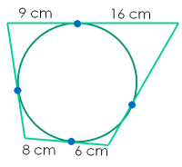
25. What is the measure of angle RPS?  A. $25 °$ B. 125$°$  C. $85 °$ D. $35 °$ | 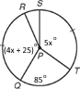 |  |  | 26. Find x.  A. 15 B. 17  C. 19.25 D. 19.5 | 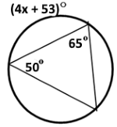
27. What is the measure of the intercepted arc?  A. $50°$ B. $53°$  C. $56°$ D. $59°$ |  | 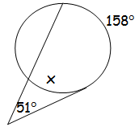 |  | 28. What is the measure of arc $\hat{BC}$?  A. 26$°$ B. $52°$  C. $90°$ D. $180°$ | 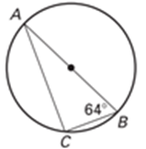
29. What is the cross-section of the figure shown?  a) b) c) 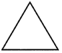 d) |  |  |  |  | 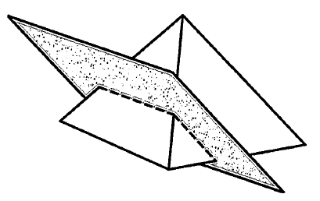

30. Find the line that is perpendicular to $y=\frac{5}{3}x – 2$ and passes through point $A( -12, 3)$.  A. $y=-\frac{3}{5}x – 2$ B. $y=\frac{5}{3}x+7$  C. $y=\frac{5}{3}x – \frac{21}{5}$ D. $y=-\frac{3}{5}x – \frac{21}{5}$ |  | 31. Find point Y that partitions the directed line segment ZX in a ratio of 4:3.  $$X(-4, 8) and Z(-10, -2)$$  A. $(-7.43, 2.29)$ B. $(-7.43, 3.71)$  C. $(-6.57, 2.29)$ D. $(-6.57, 3.71)$ |  | 32. Put ${3x}^{2}+{3y}^{2}-24x+12y+13=0$ into standard form of a circle and find the center and radius.  A. $Center:\left(-4, 2\right), r=12$  B. $Center:\left(-4, 2\right), r=16$  C. $Center:\left(4, -2\right), r=15.67$  D. $Center:\left(4, -2\right), r= 3.96$
33. Find the perimeter and area $\left(\frac{b ∙ h}{2}\right)$ of the obtuse triangle at right.  A. 51, 42 B. 50, 42  C. 49.5, 41 D. 49, 41 | 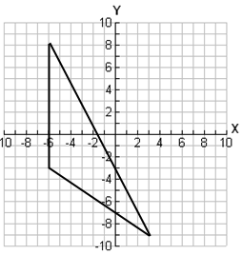 |  | 34. Convert to general form to one decimal.  $${(x-7)}^{2}+{(y+4)}^{2}=2\sqrt{7}$$  A. $x^{2}+y^{2}-14x+8y+59.71=0$  B. $x^{2}+y^{2}-7x+4y+37$ = 0  C. $x^{2}+y^{2}-14x+8y+31$ = 0  D.$x^{2}+y^{2}-7x+4y+31$ = 0
35. In a particular state, the first character on a license plate is always a letter. The last character is always a digit from 0 to 9. If V represents the set of all license plates beginning with a vowel, and O represents the set of all license plates that end with an odd number, which license plate belongs to the set V and O′?
- 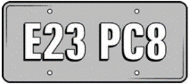 b) 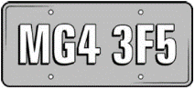 c) 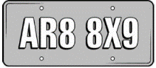 d) 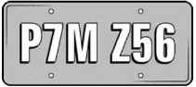

36. A random survey was conducted about gender and hair color. This table records the data. What is the probability that a randomly selected person has blonde hair, given that the person selected is male?  a) 0.51 b) 0.55  c) 0.58 d) 0.63 |  |  | 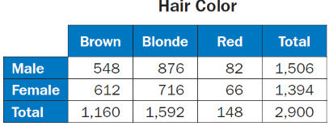
37. In soccer, a shutout is a game where the winning team does not allow the other team to score a goal. If the set W represents all wins, and S represents all shutouts, which set describe the set of all shutout wins?
- b) c) d)
38 & 39. On a separate sheet of paper, construct an angle bisector, and perpendicular bisector.

