Geometry Unit 1 Study Guide Name _________________________________________
Show all work
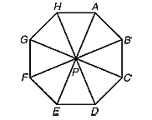
- (G.CO.5) Which clockwise rotation about point P maps C to E?

- (G.CO.2) Which describes how $∆ABC$ could be rotated to form its image $∆A'B'C'$?
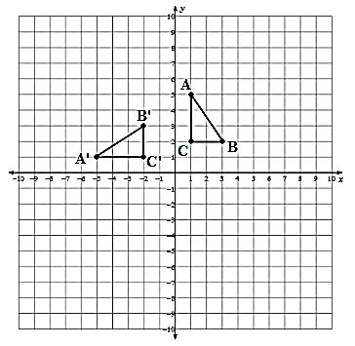

- (G.CO.4) When the point (-3, 2) is reflected across the x-axis, what is the resulting image?

- (G.CO.4) What is the image of (-3, 2) when it is translated by (x – 1, y – 4) and then reflected about the y-axis?

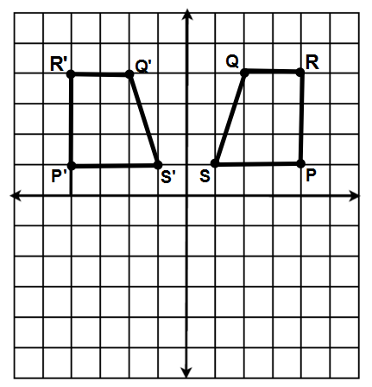
- (G.CO.4) Trapezoid $P'Q'R'S'$ is the image of trapezoid $PQRS$. Explain the
Transformation that has taken place.
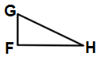
- (G.CO.5) Which of the following is not a rotation of the figure at the right?

- 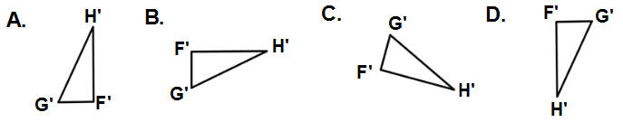
- (G.CO.5) What type of transformation is shown in the diagram below?
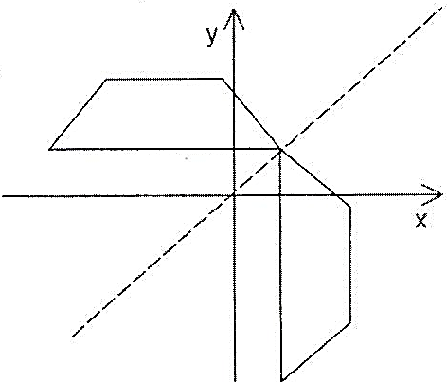

- (G.CO.4) Which of the following capital letters does not have a line of symmetry?

A. Z B. C C. O D. A

- (G.CO.4) Given the translation $\left(x,y\right)→\left(x,y+4\right)$. What is the preimage of (3, 5)?

- (G.CO.2) The translation “5 units to the left and 3 units down” in coordinate notation would be ?

(x, y)→ ( , )
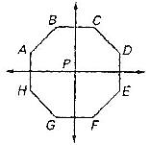
- (G.CO.3) Use the figure at right to determine which segment represents a 225° counterclockwise rotation of about P.

- (G.CO.4) If B(-2,-1) is reflected about the x-axis, then the coordinates of B’ are?

- (G.CO.4) Give an example of 2 figures that are not an isometry?

- (G.CO.2) What is the line of reflection for a transformation that maps (4, -3) to (-3, 4)?

- (G.CO.3) Which description of a rotation would map the figure below onto itself?

- (G.CO.5) The coordinates of ∆𝐿𝑀𝑁 are L (-6,8), M (-4,2), N(-10,4) and is translated $$\left(x,y\right)(x-6, y+4)$$
What are the coordinates of the new figure?

𝐿′ ________________ 𝑀′ ________________ N′ ________________

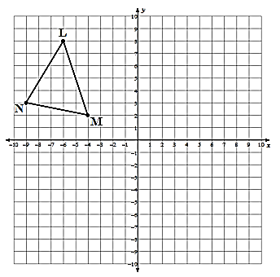
- (G.CO.5) Reflect $∆LMN$ using the rule (x, y) (x, -y).

What line did you reflect $∆ABC$across?

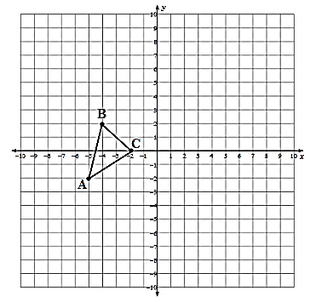
- (G.CO.5) In the coordinate plane below, rotate $∆ABC$ 180 degrees about the origin.

What are the coordinates of the new figure? Graph and label the image.

$A'$ ________________

$B'$ ______________

$C'$ ________________

- Write an example of an even, odd, and neither function.

- NEITHER: ______________________________________________________________
- EVEN: ______________________________________________________________
- ODD: ______________________________________________________________
- Determine if the given functions are even, odd, or neither.

- f(x) = 4x² + 6 __________________________________________________
- f(x) = 9x __________________________________________________
- (G.CO.5) Draw an example of a figure with a preimage in the 2nd quadrant, has reflected over the
x-axis, rotated 180 degrees and moved down by 3.

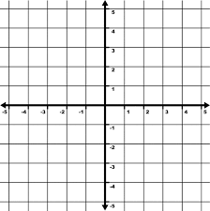

- (G.CO.5) List the sequence of transformations necessary to map $∆ABC$ to $∆A'''B'''C'''.$
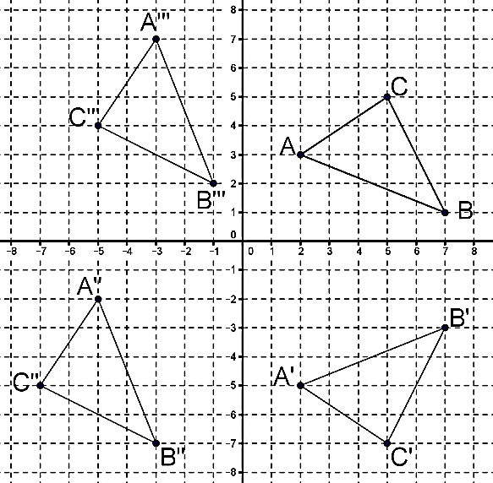
Transformation 1: _____________________________________________________
___________________________________________________________________________

Transformation 2: _____________________________________________________
___________________________________________________________________________

Transformation 3: _____________________________________________________
___________________________________________________________________________

BONUS
Solve for x.  $$\frac{2x+2}{5}=-2$$ | Solve for y.  $$3y+7-7y+10=1$$ | Solve for a.  $$3\left(a+2\right)=-2a$$

