**Unit 3 Part 1 Circles Review: Angles and Arc Measures, Segment Lengths, Tangents, Inscribed Quads**

**For each picture, write out the theorem or formula you would use to solve the problem.**



In the picture to the right, point *C* is the center.

1. You know  and need  _____________________

2. You know  and need  _____________________





3. You are looking for  ________________ 5. You are looking for _______________

4. You are looking for *m* ___________________ 6. You are looking for *m* _______________

**In the circle below, and . Find the following measures.**



7.  =

8.  =

9. =

10. =

11.  =

**For the following problems, determine which theorem to use, write an equation, and solve.**

13. 14.  find 

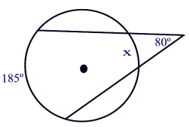 

15. 200  16.



700



17. 18.

19.  20.  and  find 



21. In the circle to the right, , , and .



Determine if  is tangent to the circle.

Show work and explain.



22. In the picture to the right, .

What is the relationship between

 and ?

23.  and  are tangent. The measure of . Find the measure of .



24.  25.  , 

Find x = ______ Find y = _______ Find ______ Find x = _______

