**Unit 3 Part 1 Circles Review: Angles and Arc Measures, Segment Lengths, Tangents, Inscribed Quads**

**For each picture, write out the theorem or formula you would use to solve the problem.**



In the picture to the right, point *C* is the center.

1. You know  and need  _____________________

2. You know  and need  _____________________





3. You are looking for  ________________ 5. You are looking for _______________

4. You are looking for *m* ___________________ 6. You are looking for *m* _______________

**In the circle below, and . Find the following measures.**



7.  =

8.  =

9. =

10. =

11.  =

**For the following problems, determine which theorem to use, write an equation, and solve.**

13. 14.  find 

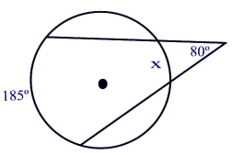 

15. 200  16.



700



17. 18.

19.  20.  and  find 



21**.  22.  , **

**Find x = ______ Find y = _______ Find ______ Find x = _______**



23. If the clock in our classroom has a radius of 7 inches, what is the arc length and area sector of the clock at 4pm? Draw a picture and show your work.

24. The area of one piece of pizza is 9π . The pizza is cut into eighths. Find the radius of the

pizza pie. Draw a picture and show your work .

25. Find the **area** and **arc length** of the shaded region.

