**Unit 5 Study Guide** Name:___________________________ S: ____

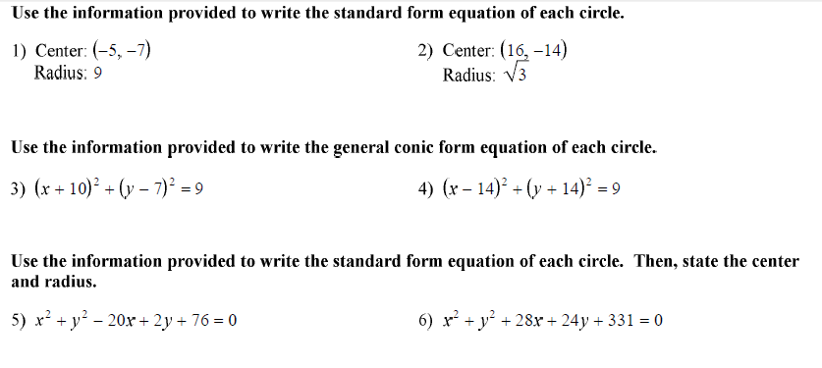

**Use the information provided to write the standard form equation of the circle**.

7) Center (0, -1) 8) Center (4, -14)  
 Point on the Circle (-13, -10) Point on the Circle (6, 11)

9) Prove or disprove that the points A(8, 6), B(8, -6) and C(-10, 0) are the vertices of an isosceles triangle inscribed in the circle centered at the origin Q and passing through the point P .

10) A new resort is being built on the short of a lake that is roughly circular. Claire also lives on the lakeshore and she finds that the new resort is directly across the lake from her house. If the lake is put on a coordinate plane with x and y in miles, the coordinates of Claire’s house are (0.5, -1.2) and the coordinates of the new resort are (-0.5, 1.2).  
a) Is the center of the lake at the origin? Explain.  
b) Find an equation that models the shoreline of the lake.  
c) If Claire’s boat is sitting at the coordinates of (0.3, 1.25), is her boat in or out of the water?

11) A local television station in Marshall County has a range of 50 miles.   
 a) Write an equation that represents the region covered by this television station.  
 b) Can a person who lives 18 miles to the East and 35 miles North of the station watch this TV station?

12) Melissa lives at the corner of 3rd Street and 28th Avenue. Her sister Rebecca lives at the corner of 27th Street and 16th Avenue. Find the cross street that:

a. is halfway between their homes

b. is  of the way from Melissa's to Rebecca's

c. separates their homes in a ratio of 3 : 1

d. separates their homes in a ratio of 1 : 5

|  |  |
| --- | --- |
| 13) ABCD has vertices A (1, 2) B (2, 5) C (4, 3) D (5, 6). Determine which type of quadrilateral this is. Prove your assertion. | 14) EFGH has vertices E (4, 1) F (-2, 3) G (2, -5) H (-4, -3). Determine which type of quadrilateral this is. Prove your assertion. |

15) Determine if point A lies on a circle with center C and point P on the circle.

a) A( 5, 0) C(0, 0) P(3, 4) b) A (0, 4) C(2, 1) P(5, 3)

16) Write the equation of the lines below in slope-intercept form.

a. Through (-4,5) and parallel to y = x- 5 b. Through (4,1), perpendicular to y = -2x -2